# **TASK-1 FOR DEVOPS**

1. Installation for Java is required for Jenkins

**Command**

sudo apt update  
 sudo apt install fontconfig openjdk-17-jre  
 java -version  
 openjdk version "17.0.13" 2024-10-15  
 OpenJDK Runtime Environment **(**build 17.0.13+11-Debian-2**)**  
 OpenJDK 64-Bit Server VM **(**build 17.0.13+11-Debian-2, mixed mode, sharing**)**

**Screeenshot** :

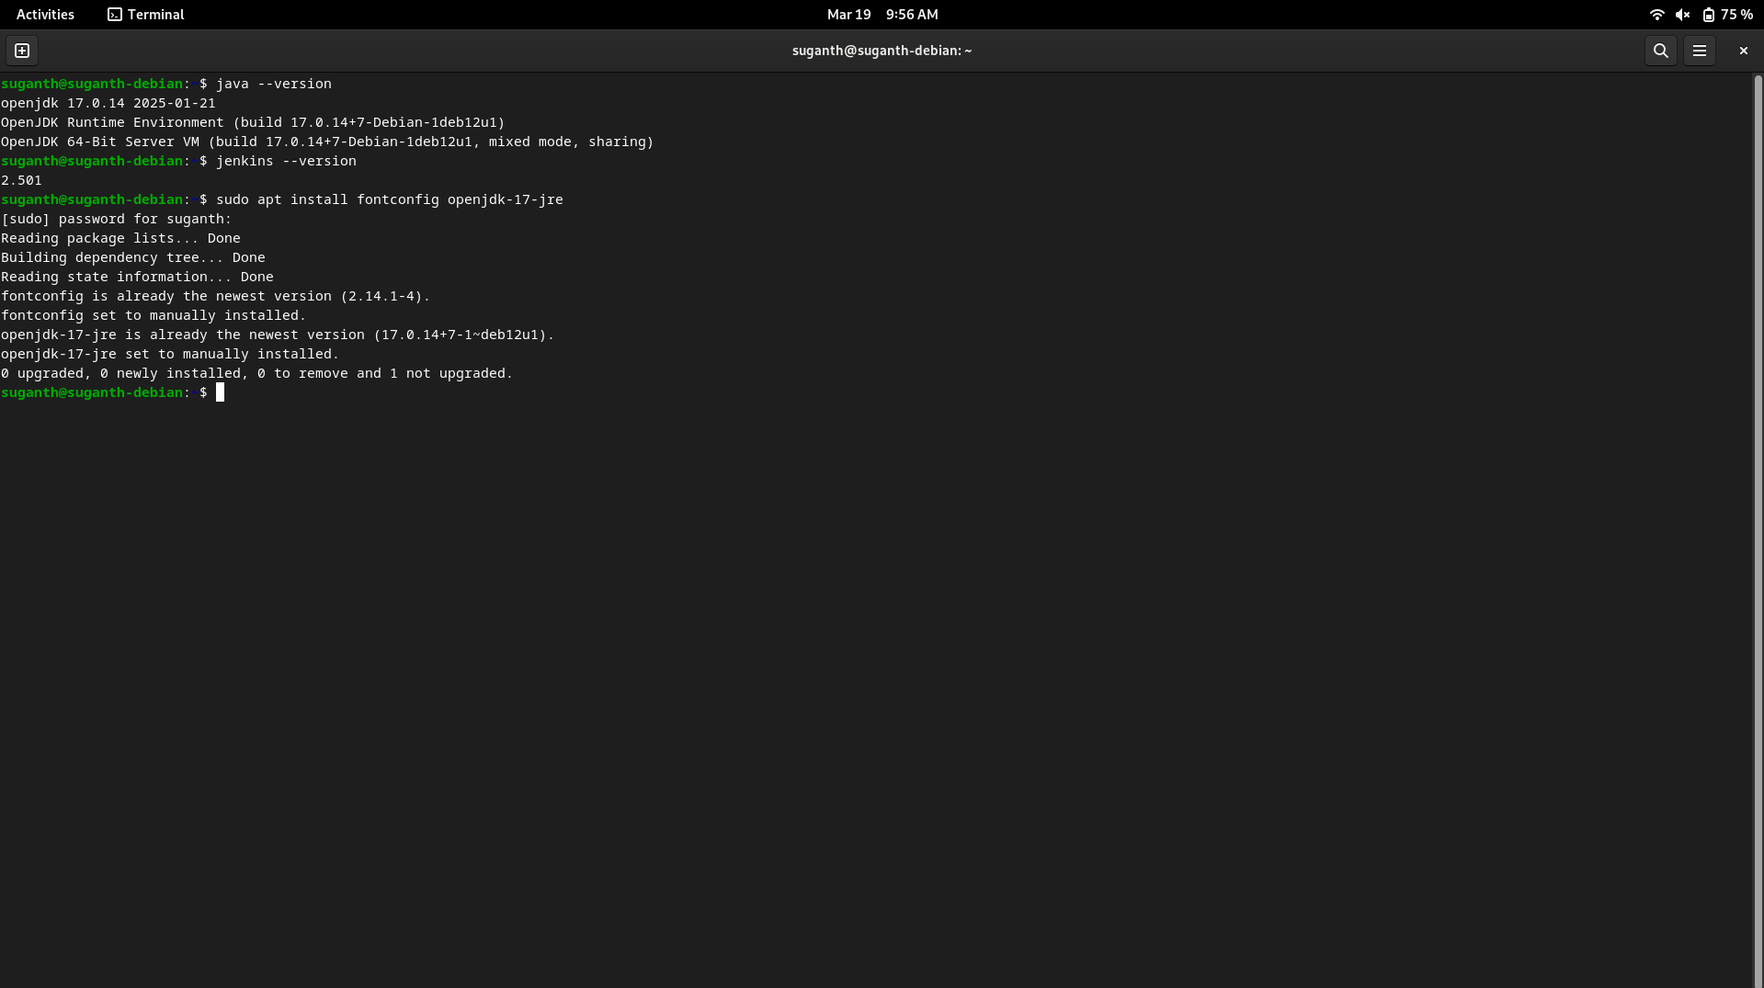

The Java JDK has been successfully installed.

1. Install Jenkins

**Command :**

sudo wget -O /usr/share/keyrings/jenkins-keyring.asc \

https://pkg.jenkins.io/debian-stable/jenkins.io-2023.key

echo "deb [signed-by=/usr/share/keyrings/jenkins-keyring.asc]" \

https://pkg.jenkins.io/debian-stable binary/ | sudo tee \

/etc/apt/sources.list.d/jenkins.list > /dev/null

sudo apt-get update

sudo apt-get install jenkins

**Screenshot :**

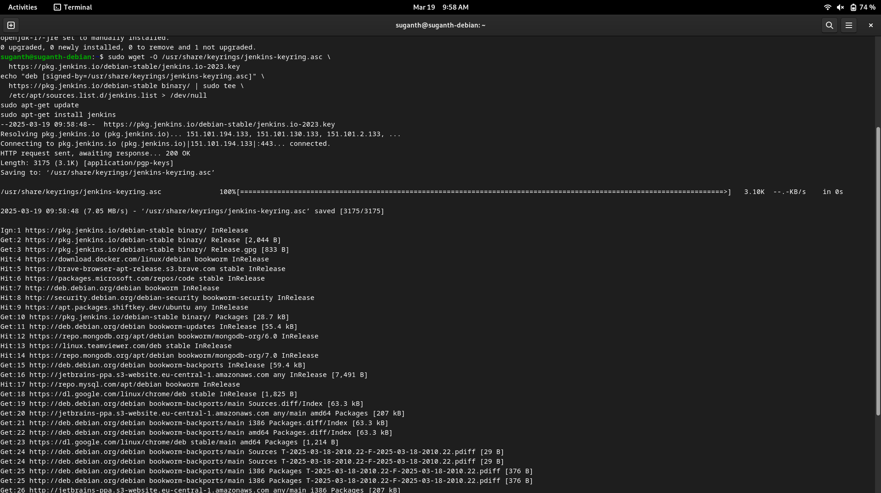

Jenkins has been successfully installed.

Now got to the Jenkins page in the browser by running localhost:8080 and login with your credentials.

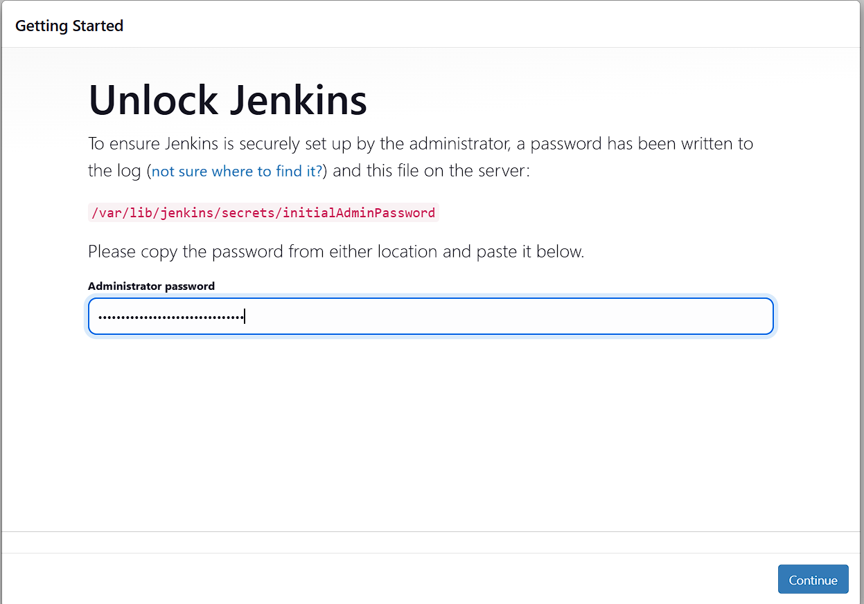

Install the Suggested plugins required and followed by Creating the First Admin User

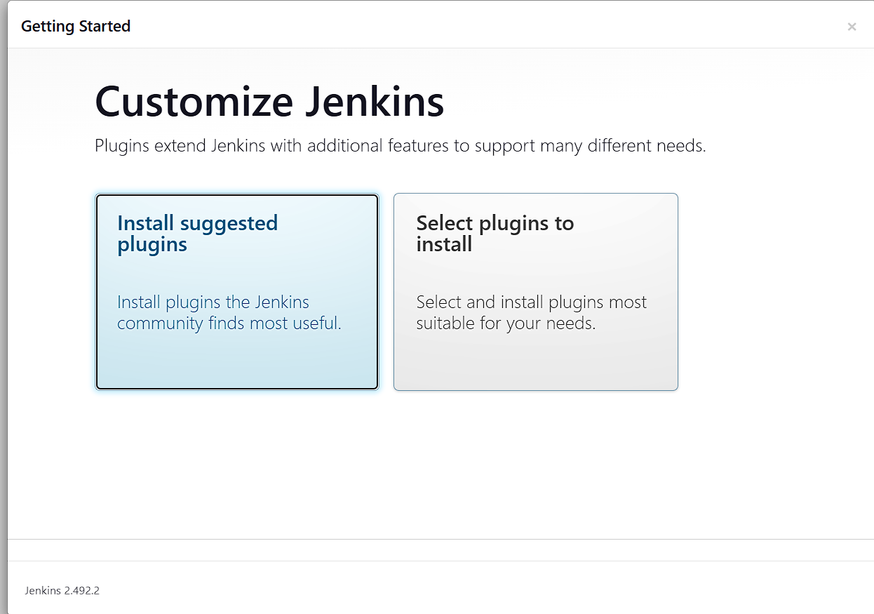

Now Jenkins is ready to use

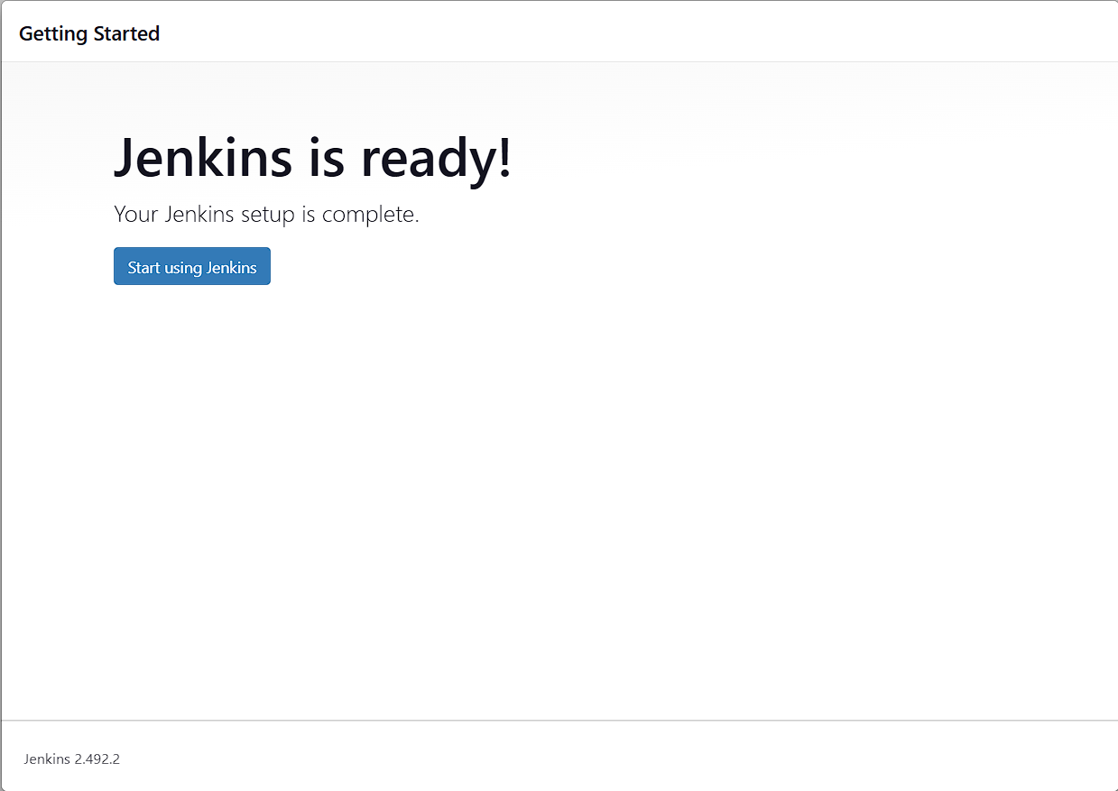

Now create a new item

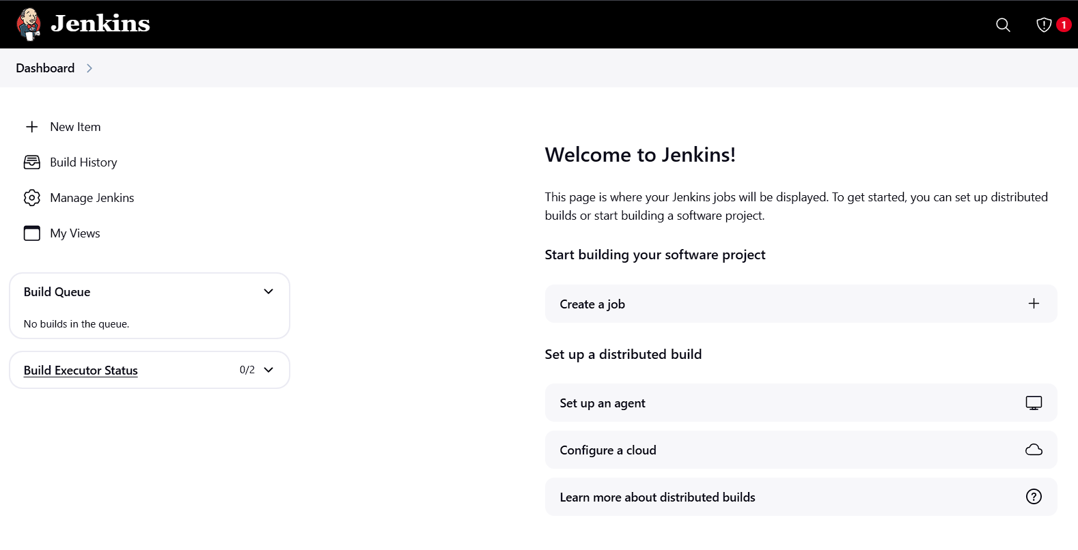

Give an item name and select the item type as free-style project

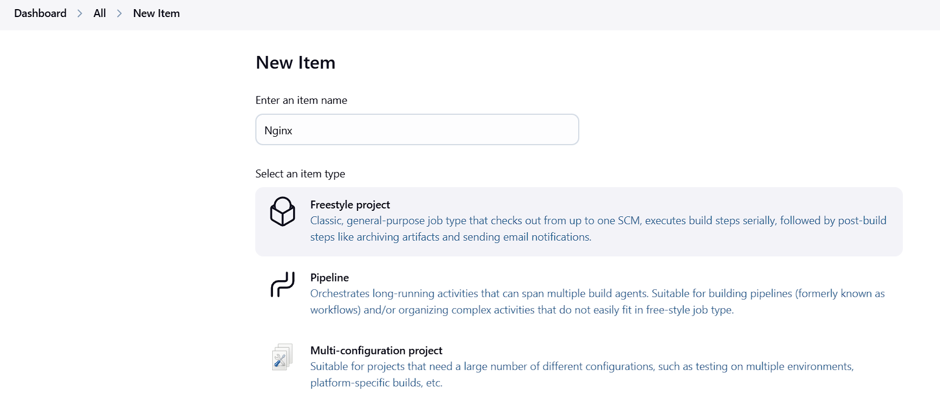

Build the steps using the commands

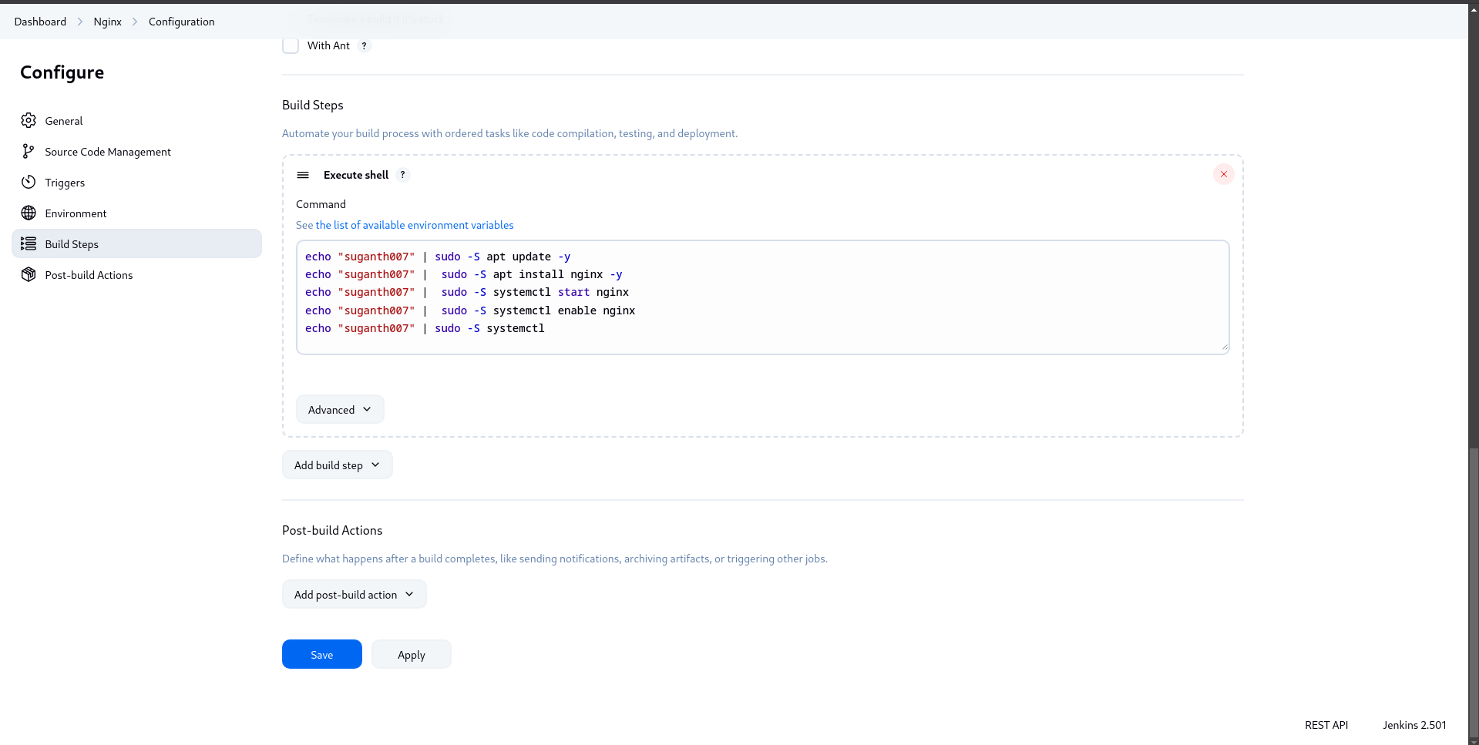

After the successful compilation of the build, Nginx will be opened in localhost, once the ip address is given

